**Model Development Phase Template**

|  |  |
| --- | --- |
| Date | 15 April 2024 |
| Team ID | Team-738205 |
| Project Title | Dog Breed Identification Using Transfer Learning |
| Maximum Marks | 10 Marks |

**Initial Model Training Code, Model Validation and Evaluation Report**

The initial model training code will be showcased in the future through a screenshot. The model validation and evaluation report will include a summary and training and validation performance metrics for multiple models, presented through respective screenshots.

**Initial Model Training Code (5 marks):**

Paste the screenshot of the model training code.

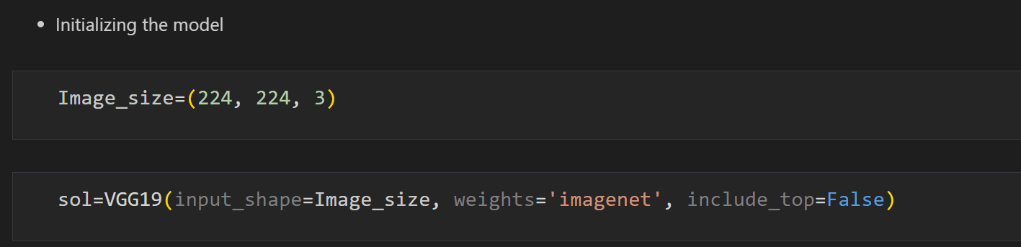

**Model Validation and Evaluation Report (5 marks):**

|  |  |  |
| --- | --- | --- |
| **Model** | **Summary** | **Training and Validation Performance Metrics** |
| Model 1 |  |  |